**Image Recognition with Convolutional Neural Networks**

In this tutorial, you will learn the basics of image recognition and convolutional neural networks. Image recognition, also known as computer vision, is a scientific field that deals with the methods in which computers can gain a deep understanding of their surroundings from digital photos or videos.

**Part 1: How does CNN work?**

At a high level, image recognition/computer vision is usually achieved through the use of neural networks, specifically *convolutional neural networks*. Here’s a brief explanation of what a convolutional neural network is:

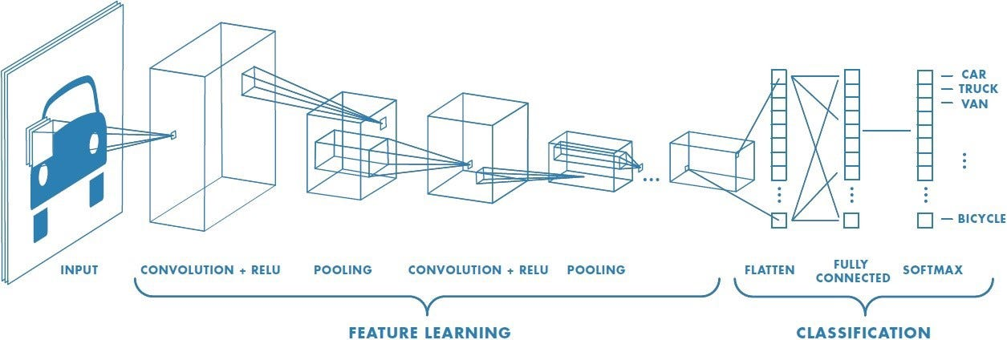

**Step 1: Convolution**

One of the most important concepts to understand is that every image or frame of a video is just a matrix of numbers. Essentially, this means that every pixel can be represented by a number. Whether it be black and white or fully coloured, each pixel of each image can be represented by just a number, or a few numbers. For example, each black and white pixel will have a value from 0–255 (0=black, 255=white), and each coloured pixel will have 3 values of both red, green, and blue, all ranging from 0–255. Every pixel can be represented by a single number.

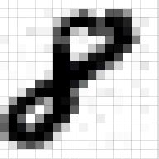 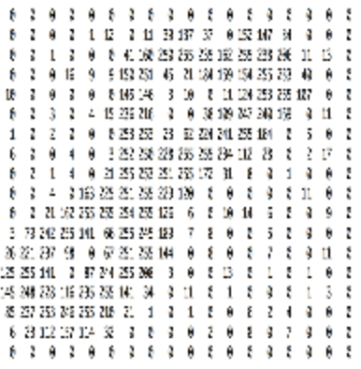

In this step, a filter is chosen (initially randomized) to move pixel by pixel from left to right and top to bottom. Before each move, matrix multiplication is performed on the pixels that the filter covers. After each matrix multiplication, the filter will slide over by one pixel. For example, here, is the initial matrix that will be convolved over (i.e. the initial image):

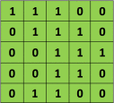

Here is the “filter” that will convolve over the matrix above (with weights that are trained):

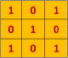

In the image below, the feature map (convolved feature) is calculated by using convolution.



The result of each matrix multiplication is added into what we call a feature map, which is essentially the result. This feature map will create an entirely new image. Many of these filters can be used for things like edge detection, sharpening, blurring, and more. More often than not, filters are used to detect certain features that are useful towards classifying objects. Here is an example:



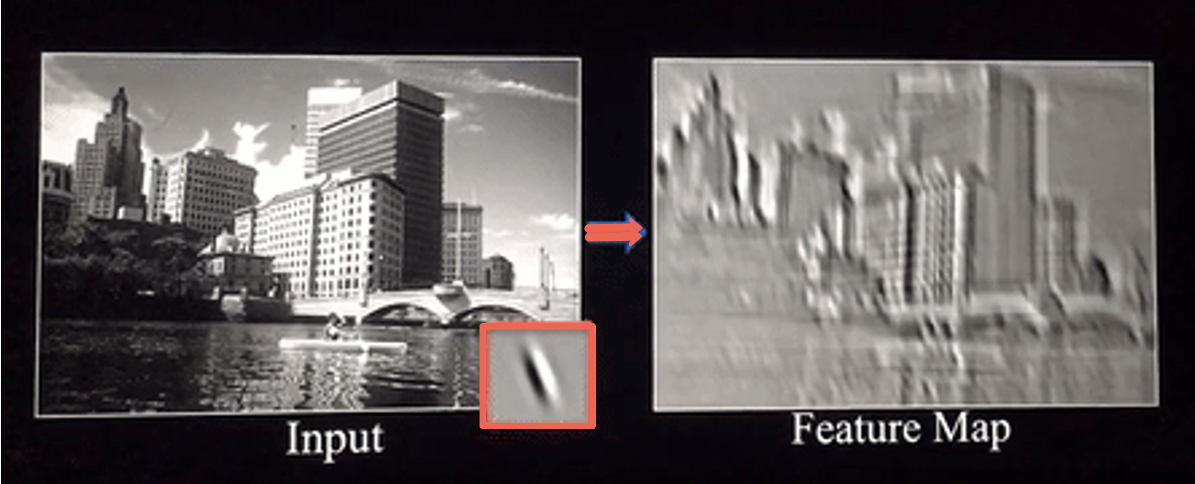

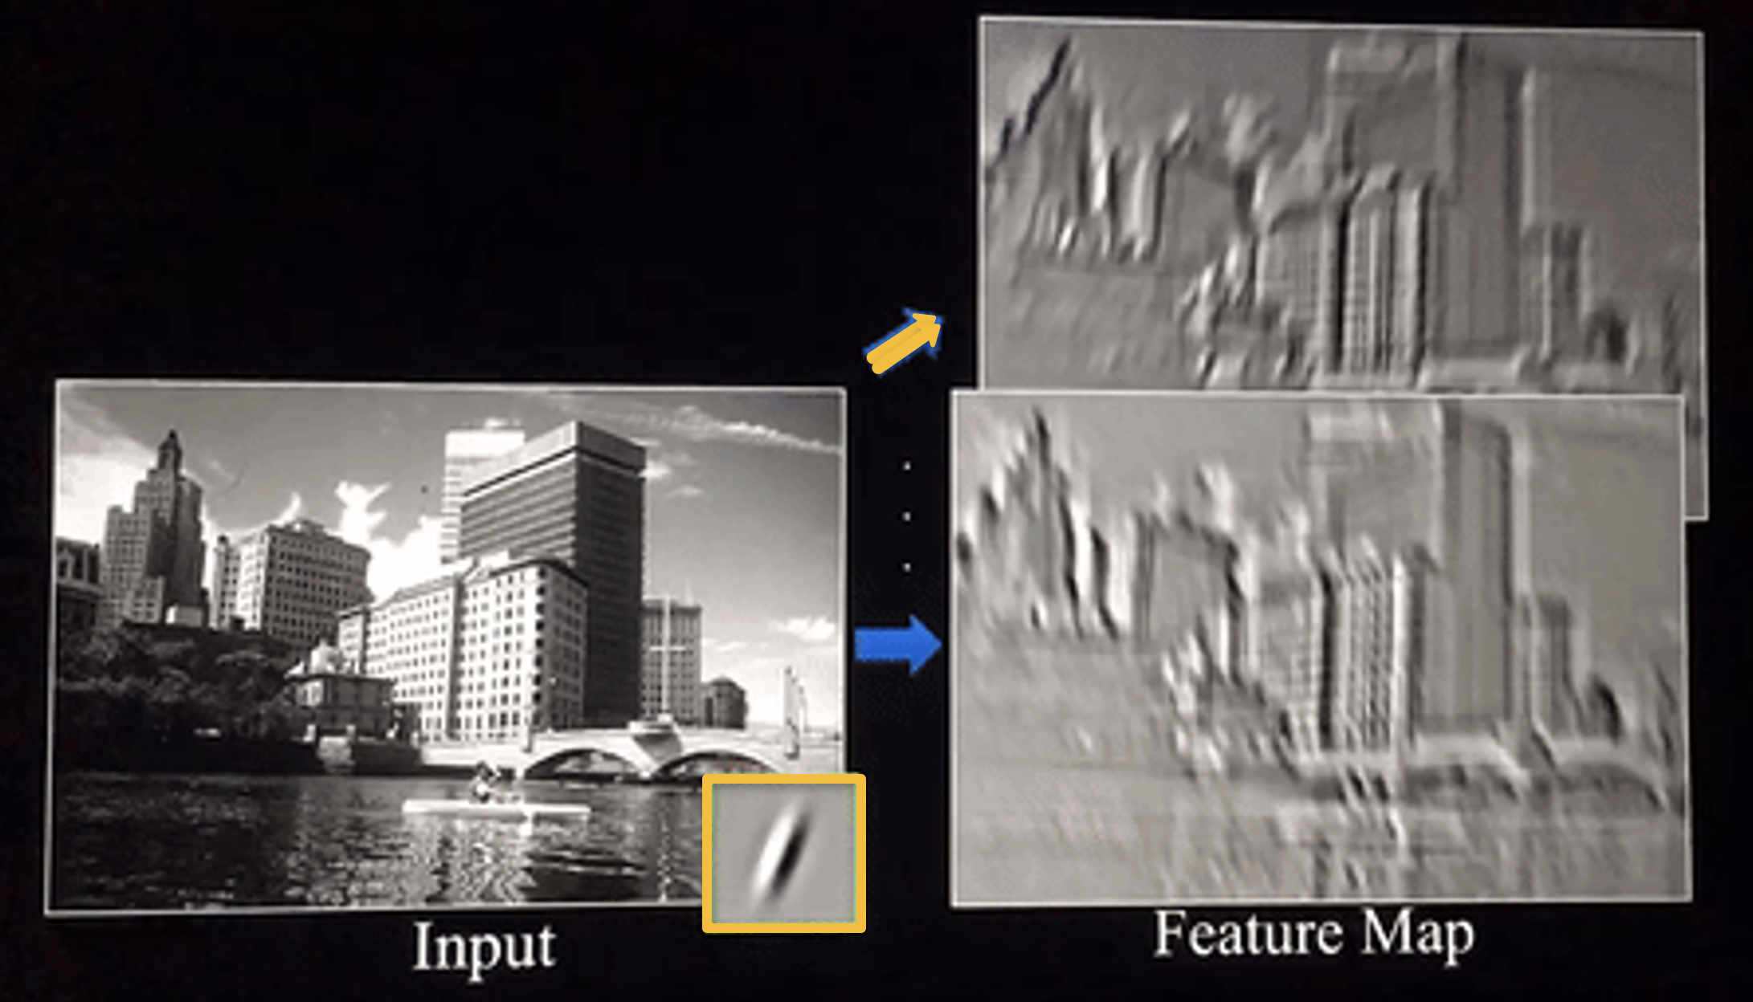

Example of convolution operation

As you can see, different filters will create different feature maps and results, and they will identify different features. In practice, the CNNs will “learn” the values of all of its filters, but we still need to specify several features, including filter size, number of filters, the architecture of the network, etc.

**Step 2: Feature Map Post Rectified Linear Unit (ReLU):**

Rectified Linear Unit (ReLU) is an activation function that aims to introduce non-linearity to the model. As a short review, activation functions are used to introduce non-linearity, which means that the model will be able to learn more complex patterns. Without activation functions like ReLU, the model will never be able to learn anything other than a linear relationship.

In short, ReLU is an element-wise operation, which means that it is applied per pixel, and it replaces all negative values in the feature map with zero. Essentially, all-black values (i.e. negative values) are negated.

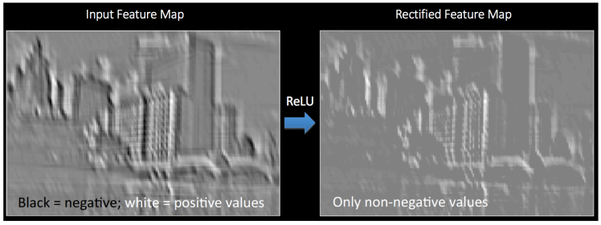

Example of rectified feature map post-ReLU (No Black as there is no negative values)

**Step 3: Pooling**

Pooling is mainly used to reduce the dimensionality of each feature map while retaining the most important information. There are a few variations of pooling, including Max, Average, Sum, and many more. Since the most common type is Max Pooling, we will focus on that.

Max Pooling works by defining a spatial window and taking the largest element from the feature map within that window. Even though Max Pooling has been shown to be the most effective method of pooling, we could still take the average or sum of all the elements in that window as well. Here is an example of the Max Pooling operation after convolution and ReLU. In this case, we used a 2x2 window.

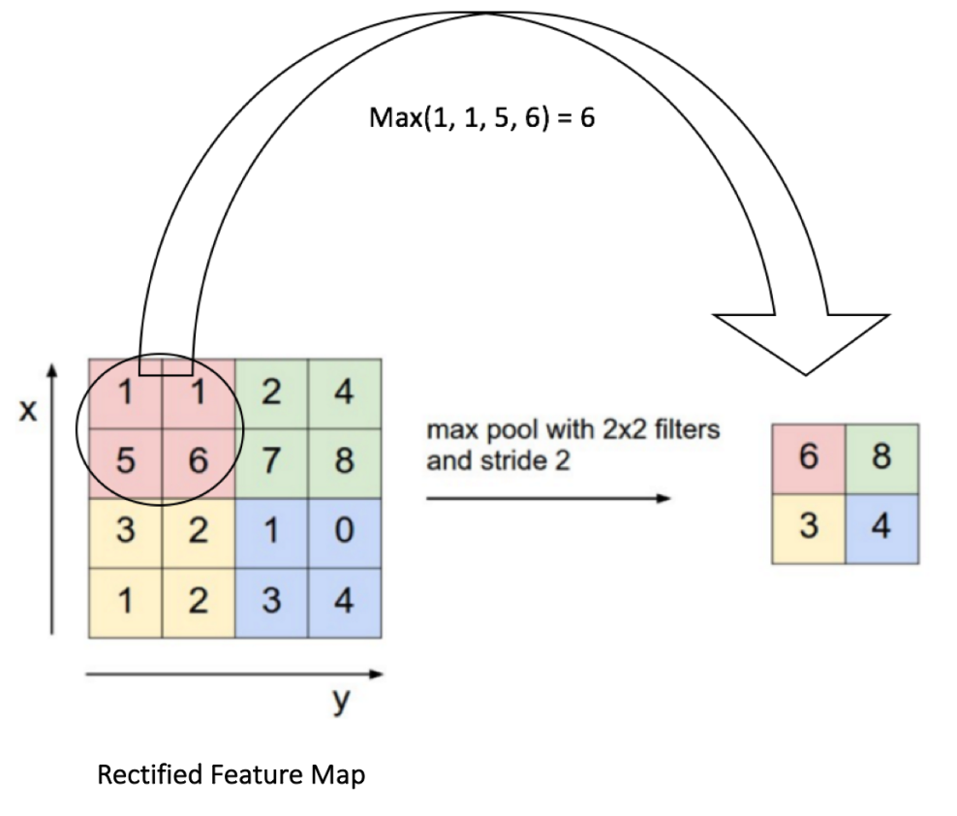

In this case, we slide our 2x2 window by 2 cells each time so that there is no overlap and take the maximum value in each window/region. This is done to reduce the dimensionality and make the feature map simpler for the model. Here is an example of the effect of Max and Sum Pooling on a rectified feature map:

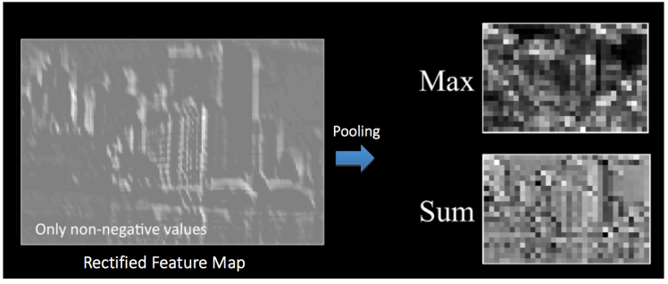

Sum pooling is a type of pooling that takes the sum of each region in the feature map. It is used when we want to retain the overall structure of the feature map while reducing its spatial dimensions. Max pooling is a down-sampling technique used in convolutional neural networks (CNNs) to reduce the spatial dimensions of feature maps by selecting the maximum value within each small region. Therefore, Sum pooling is similar to max pooling, it reduces spatial dimensions, but it retains more information about the overall intensity of the region than max pooling.

**Step 4: Image classification exercise with CNN:**

Now that you know how CNNs work, let’s apply our knowledge to a real-life problem using Python and the Keras Library.

## **Part2: Problem Description: Cat and dog image recognition**

We are trying to build an image recognition model that can correctly distinguish between the image of a cat and a dog using CNNs. Therefore, we have obtained a training dataset with 2000 images of cats and dogs and a test set with 400 images to evaluate the performance of our image classification model.

**1) Installing TensorFlow**

TensorFlow is an open-source numerical computation library and platform for machine learning and artificial intelligence. Keras is a simple-to-use package but a powerful deep-learning library for Python. In this post, we’ll build a simple Convolutional Neural Network (CNN) and train it to solve a real problem with TensorFlow and Keras. Start by installing TensorFlow library:

!pip install tensorflow

**2) Importing packages**

Every Keras model is either built using the Sequential class, which represents a linear stack of layers, or the functional Model class, which is more customisable. We’ll be using the simpler Sequential model since our CNN will be a linear stack of layers. Lets import all the required packages.

import numpy as np

import tensorflow

from tensorflow.keras.layers import Conv2D, Activation, MaxPooling2D, Dense, Flatten

from tensorflow.keras import Sequential

The Sequential constructor takes an array of Keras Layers. We’ll use 3 types of layers for our CNN: **Convolutional**, **Max Pooling, Flatten and Dense**.

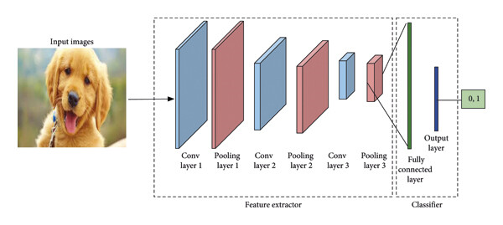

The first layer in any sequential model must specify the input_shape, so we do so on Conv2D, which is used for images, while Conv3D is used for videos. Once this input shape is specified, Keras will automatically infer the shapes of inputs for later layers.

The filters argument sets the *number* of convolutional filters in that layer. These filters are initialised to small, random values using the method specified by the kernel_initializer argument. During network training, the filters are updated in a way that minimises the loss. So, over the course of training, the filters will learn to detect certain features, like edges and textures, and they might become something like the image below:

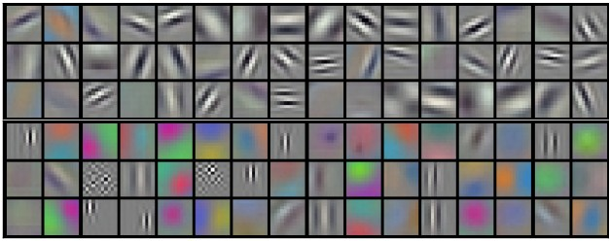

**3) Uploading/accessing the image dataset files in Google Colab:**

The image datasets are large files; the input file, for example, is 1.5GB. It will take a very long time to upload image training and test data files to Google Colab using the traditional “Session Storage Upload.”

1. Download the datasets from your blackboard account onto your local machine storage.
2. Create/log into your own free Google Drive Account with a capacity of 15GB.
3. Upload the datasets from your local machine storage to your personal Google Drive account using the “New” and then “File upload” functionality.



1. Launch Google Colab and ensure you are logged into your personal Google Drive, where you uploaded the image datasets. Click “Mount Drive”, then grant permission to share your drive with Google Colab.



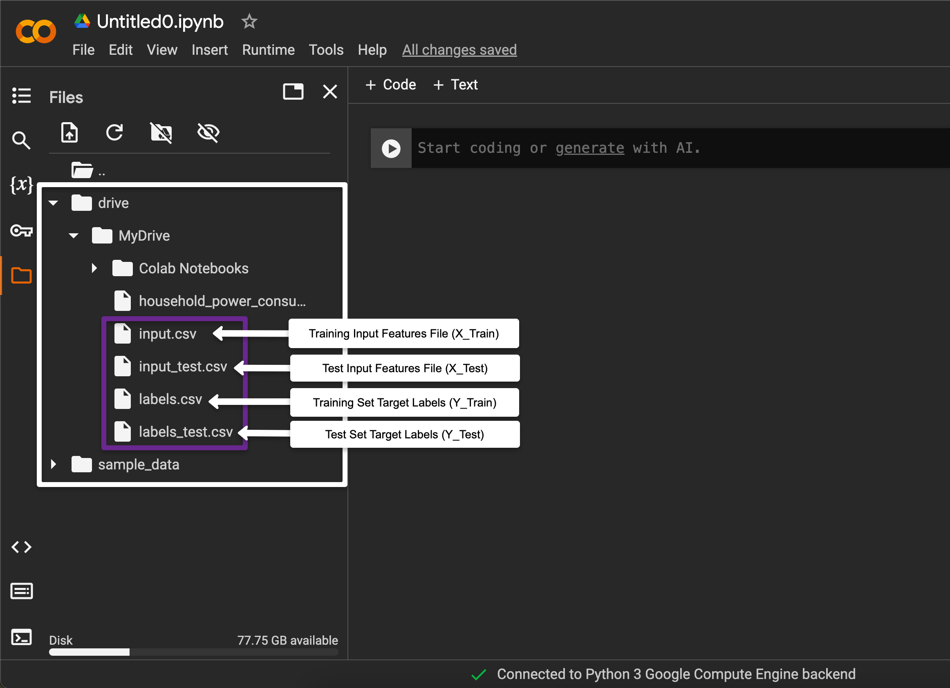

Alternatively, you can use the following code to count your drive.

from google.colab import drive

drive.mount('/content/drive')

**4) Loading your data**

Copy and paste each file path and use the NumPy package to load the files. Numpy loadtxt enables you to load numeric data stored in a text file. What is this? So, for example, if you have row-and-column data stored in a text file, where the numbers are separated by commas (also called CSV file), you can use Numpy loadtxt to load the data into your Python environment.

X_train = np.loadtxt('/content/drive/MyDrive/input.csv', delimiter=',')

Y_train = np.loadtxt('/content/drive/MyDrive/labels.csv', delimiter=',')

X_test = np.loadtxt('/content/drive/MyDrive/input_test.csv',delimiter=',')

Y_test = np.loadtxt('/content/drive/MyDrive/labels_test.csv',delimiter=',')

**5) Understanding your data dimensions**Check the data shape in each dataset:

print("Shape of X_train: ", X_train.shape)

print("Shape of Y_train: ", Y_train.shape)

print("Shape of X_test: ", X_test.shape)

print("Shape of Y_test: ", Y_test.shape)

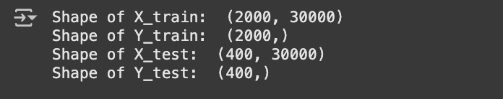

**6) Preparing the image datasets**

We need to reshape data sizes. In the training input data, the 2000 is the number of training images in the training set. However, every image is 100x100 pixels; each has a Green-Red-Blue (GRB) value. Thus, the data shape should be converted to three elements: the number of images and the dimensions of the image with 100x100x the number of GRB values 3 = 30000.

X_train = X_train.reshape(len(X_train),100,100,3)

Y_train = Y_train.reshape(len(Y_train),1)

X_test = X_test.reshape(len(X_test),100,100,3)

Y_test = Y_test.reshape(len(Y_test),1)

Check the new data shape in each dataset:

print("Shape of X_train: ", X_train.shape)

print("Shape of Y_train: ", Y_train.shape)

print("Shape of X_test: ", X_test.shape)

print("Shape of Y_test: ", Y_test.shape)

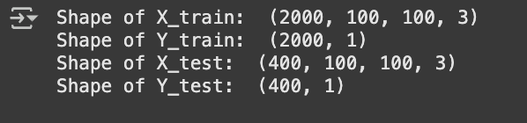

To inspect the values for each image instance, for example, the first image, you will notice that the highest value is 255 because the RGB intensity value is on a scale of 0 to 255.

X_train[1,:]

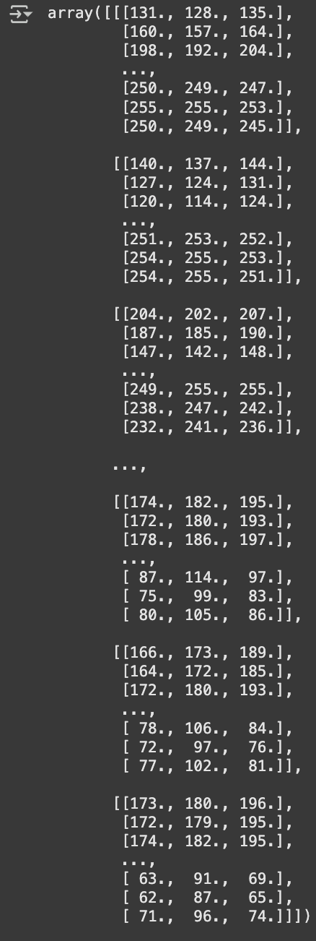

Due to the variation of ranges, we need to scale (normalise) our data between 0 and 1; since the minimum is already known to be zero, we use a maximum normalisation.

X_train = X_train/255.0

X_test = X_test/255.0

Take a look now at the same instance, you will see that all the values are normalised with a maximum value of 1 instead of 255.

X_train[1,:]

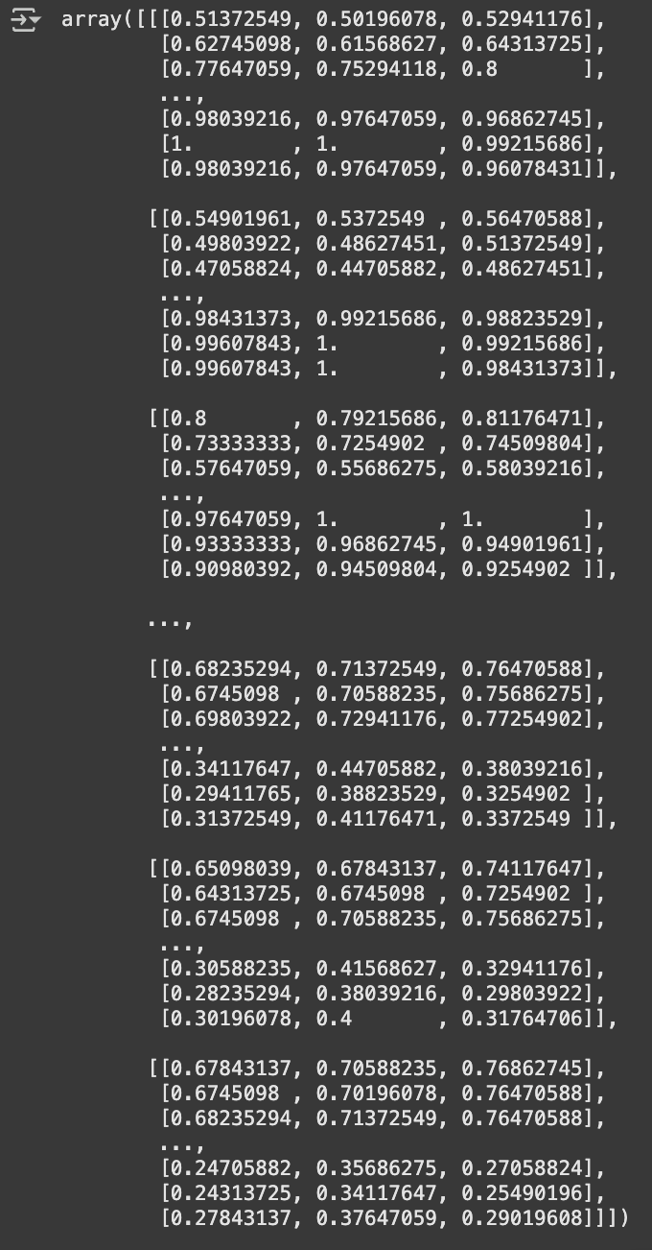

Let’s display any random images now and see what they look like. To create a display, you need a matplotlib package. To make a random index value for an image from your data, import the random package.

import matplotlib.pyplot as plt

import random

idx= random.randint(0,len(X_train))

plt.imshow(X_train[idx,:])

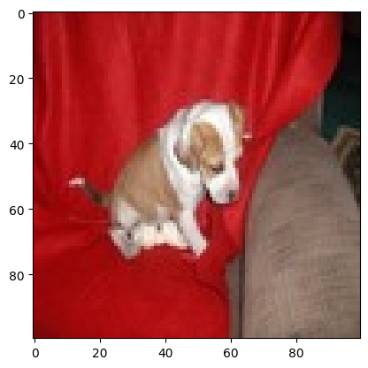

**7) Initiating CNN for feature extraction and modelling**

Every ANN has an architecture, and CNN has its own. The sequential model means that our CNN layers are going to be stacked up in a certain sequence. First, we have the convolution layer, the max pooling layer, and then another convolution layer, the max pooling layer. Then, we have some fully connected layers (Dense), etc.

Sequential shows how the CNN architecture is formed. Inside the sequential, we write the layers. In the convolutional layer Conv2D, we need the number of filters we will use before updating the network parameters; let’s say it is 32.

Also, for the convolutional layer Conv2D, we need the size of the filter we need to use, say a 3x3 pixel filter.

For the convolutional layer Conv2D, you need the activation function. For the first layer in Keras, we need to state the input image shape; what is the shape of image inputs that the CNN is expecting.

The second layer is the MaxPooling2D, where we state the deep filter size. You can then use another convolutional layer Conv2D, but without the need for input size, as this is a hidden layer.

“flattening” refers to the process of converting all of the multi-dimensional features to be processed by a dense layer of fully connected neurons for classification learning which you will need to specify the number of neurons. See the figure below:

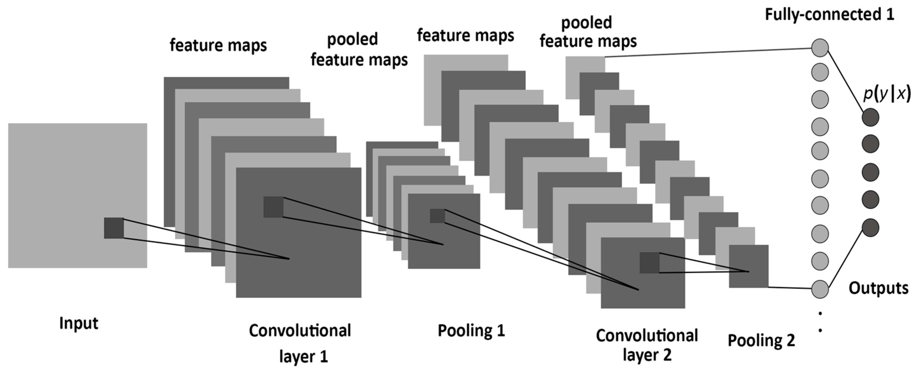

model = Sequential([

Conv2D(32,(3,3),activation = 'relu',input_shape=(100,100,3)),

MaxPooling2D((2,2)),

Conv2D(32,(3,3),activation = 'relu'),

MaxPooling2D((2,2)),

Flatten(),

#The above layers are for feature extraction

#The following layers are for modelling (learning) with one hidden layer and a final output layer with a sigmoid activation function.

Dense(64, activation='relu'),

Dense(1, activation='sigmoid')

])

There is another way of stacking the layers below:

model = Sequential()

model.add (Conv2D(32,(3,3),activation = 'relu',input_shape=(100,100,3)))

model.add(MaxPooling2D((2,2)))

model.add( Conv2D(32,(3,3),activation = 'relu'))

model.add(MaxPooling2D((2,2)))

model.add(Flatten())

#The above layers are for feature extraction

#The following layers are for modelling (learning) with one hidden layer with ReLU AF, and a final output layer with a sigmoid activation function.

model.add(Dense(64, activation='relu'))

model.add(Dense(1, activation='sigmoid'))

**8) Image Classification Modelling**

Now, we need to set the cost function for backpropagation, and we use the compile function in Keras. Since we have a binary classification task, we use a“*binary cross entropy”* cost function as a loss function to update the weights and biases. For that, we need an optimiser like *“adam”.* Also, you should indicate which performance evaluation metric you want to optimise the network parameters towards, let’s say *“accuracy”*. For further information regarding loss functions in Keras, go to <https://keras.io/api/losses>. For further information on optimisers in Keras, go to <https://keras.io/api/optimizers>. If you want to use SGD, you can also specify the learning rate.

#opt= keras.optimizers.SGD(learning_rate=0.001)

#model.compile(loss = 'binary_crossentropy' , optimizer ='opt', metrics=['accuracy'])

In some scenarios, adaptive optimisation algorithms, such as Adam, have shown better optimisation performance than stochastic gradient descent1 (SGD). Choosing the right optimiser is essential because different optimisers are better suited to different problems. Some popular optimisers include SGD, Adam, and RMSprop. SGD is simple but effective, while Adam and RMSprop may be more computationally intensive but often converge faster. Therefore, we will proceed with *“adam”.*

The “compile” function helps train and continue to train the model on multiple epochs. For example, if you want to stop and resume training instead of using *“model.fit”,* use *“model.compile”* which allows you to continue training if you need further accuracy improvement. Note that “RMSProp” is also considered to be one of the best default optimisers that makes use of decay and momentum variables to achieve the best accuracy of image classification.

model.compile(loss = 'binary_crossentropy' , optimizer ='adam', metrics=['accuracy'])

Now the inputs, CNN architecture and outputs are defined, we need to fit the algorithm to training data. Batch Size is among the important hyperparameters in Machine Learning. It is the hyperparameter that defines the number of samples (images) to work through before updating the internal model parameters. It can be one of the crucial steps to making sure your models hit peak performance.

model.fit(X_train, Y_train, epochs = 5, batch_size = 64)

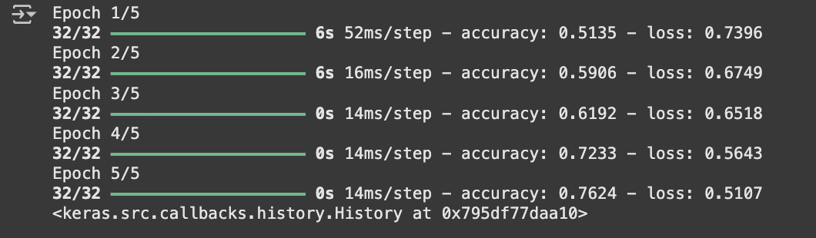

Observe that by decreasing the loss, the accuracy increases. Also, when you run *“****model.fit****”* again, observe that you resume the training, and the loss continues to decrease while the accuracy improves further.

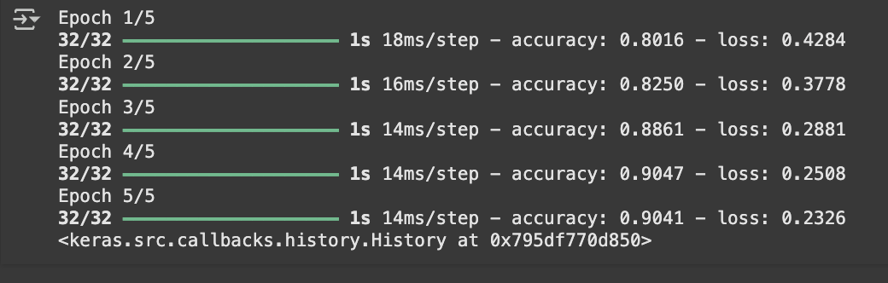

**9) Model Test Performance Evaluation**

Let’s evaluate the model on the test dataset. The test accuracy is 0.66, which is very low; this may be due to training the model to achieve 0.91 training accuracy by overfitting the training data.

model.evaluate( X_test, Y_test, batch_size = 40, verbose=0)



**10) Making Predictions (Image Classification) on Unseen Data**

Let’s make predictions on randomly selected images from the test dataset (unseen data). Here, you will see the image before the machine learning model recognises it so that you can verify it by eye first, whether it is a **dog (Class 0) or cat (Class 1)**, against what the model predicts.

Then, perform the classification on the same image you verified with the model you built. Remember you have only one image and must pay attention to its dimensions, thus reshaping that image to 100x100x3.

idx2 = random.randint (0,len(Y_test))

plt.imshow(X_test[idx2,:])

plt.show()

y_pred = model.predict(X_test[idx2,:].reshape(1,100,100,3))

print(y_pred)

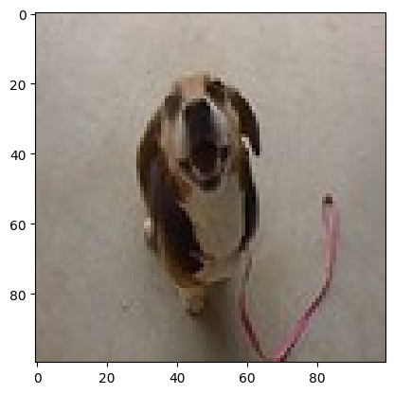

1/1 [==============================] - 0s 29ms/step

[[0.05446606]]

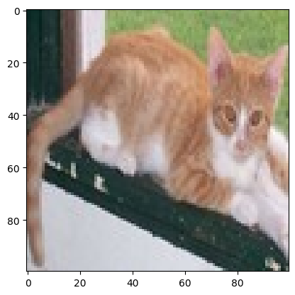

1/1 [==============================] - 0s 34ms/step

[[0.93890935]]

Notice that the classification is produced in a probability form due to using the Sigmoid function at the output; the closer the output to 1, the more likely the image is for a cat, and the closer to zero, the more it is a dog. We can build a function to translate this success criterion by defining a prediction probability threshold of 0.5 (y_pred > 0.5).

# If you want the model to actually produce a prediction of Cat or Dog output

idx2 = random.randint (0,len(Y_test))

plt.imshow(X_test[idx2,:])

plt.show()

y_pred = model.predict(X_test[idx2,:].reshape(1,100,100,3))

if (y_pred > 0.5):

pred = 'Cat'

else:

pred = 'Dog'

print("The model prediction is a ", pred)

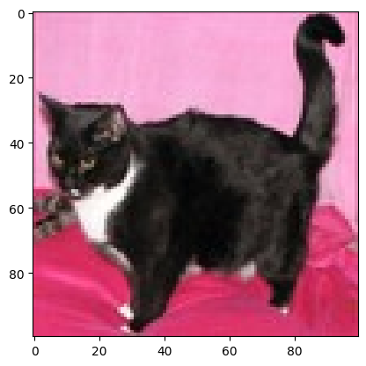

1/1 [==============================] - 0s 46ms/step

The model prediction is a CAT

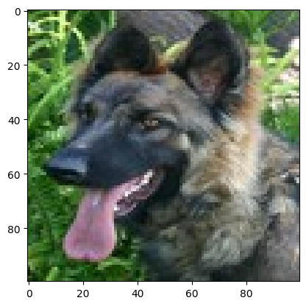

1/1 [==============================] - 0s 46ms/step

The model prediction is a DOG

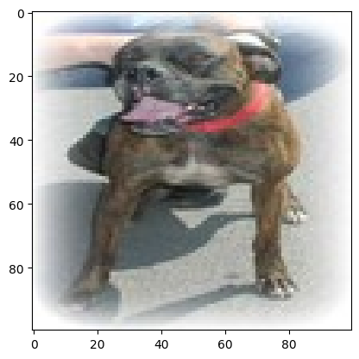

1/1 [==============================] - 0s 25ms/step

The model prediction is a CAT